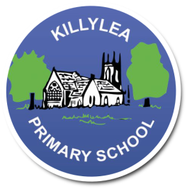
Killylea Primary School

Small School, Big Opportunities
Tel/Fax: 028 3756 8621
www.killyleaps.co.uk
plowry686@c2kni.net
Killylea Primary School
150 Killylea Road
Killylea
Co. Armagh
BT60 4LN

BT60 4LN

Website: www.killyleaps.co.uk
Killylea Primary School

4th October 2022
Dear P4-P7 Parents,
Our school choir (all P4-P7 welcome) will be singing at Killylea Methodist Church Harvest on Monday 10th October.
The Church service will run from 7.30pm-8.30pm.
Please ensure that all pupils who are taking part are at Church no later than 15mins before service starts (7:15pm) and dressed in full school uniform.
Please return reply slip to confirm attendance by Friday 7th October.
Yours Faithfully,
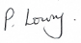
-------------------------------------------------------------------------------------------------------------------------------------------------
Methodist Church Harvest Service – Monday 10th October 2022

Pupils name: ___________________________________

Please tick one option and return this form to school before Friday 7th September.

Will be attending

Will not be attending

Signed: __________________________________________________ Dated: __________________________

