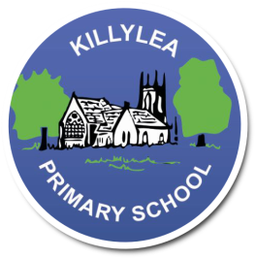
Killylea Primary School

Small School, Big Opportunities
Tel/Fax: 028 3756 8621
www.killyleaps.co.uk
plowry686@c2kni.net
Killylea Primary School
150 Killylea Road
Killylea
Co. Armagh
BT60 4LN

BT60 4LN

Website: www.killyleaps.co.uk
Killylea Primary School

28th April 2022
Dear Parents
Re: Uniform Orders
P1-P3: School sweatshirt/sweat-cardi, plain navy jogging bottoms (no logo), navy/black trainers (plain with Velcro – unless child can tie laces), blue/white polo shirt, grey socks.
P4-P7: School Sweatshirt/sweat-cardi, grey skirt/pinafore/trousers, blue/white polo shirt, black shoes, grey socks/tights.
Pupils may still wear blue and white sundresses or grey shorts during the Summer term.
The previous knitted jumpers and cardigans will still be acceptable.
As usual we will keep a supply of uniform in school for our new P1 entrants to try on during their induction afternoon and purchase.
We currently have a small quantity of knitted jumpers and cardigans available which we wish to sell off at a reduced price of £5 per item (previously was £15-£17), these will be sold on a first come, first served basis.
Please see attached order form and price list. Email complete order to emaguinness300@c2kni.net by Monday 9th May and make payment for your total via parent pay.
NO orders will be accepted in school after this date. You can still order via school trends website but will incur a postage charge.
All uniform must be labelled with child’s name. To raise funds, we have partnered up with a company called ‘My nametags’ who give us commission of 24% for every order. To order from ‘My nametags’ use school ID 51857 when placing order. See attached information sheet which includes discount code for orders.
P1-3 pupils will not require school bags. We will provide each child with a book back for their reading books. Pupils should only bring this and their lunch bag. P4-P7 will need a school bag.
Yours Faithfully
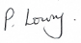
Principal

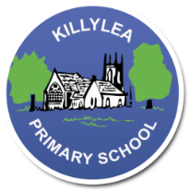
Killylea Primary School Uniform Order Form 2021/2022
We no longer hold a supply of school uniforms. Ordering will be completed once per year. You can also order directly from ‘School Trends’ anytime during the year but prices are slightly greater this way and also incurs an additional postage charge of £2.99.
Item | Size | Quantity | Individual Price | total
Storm Dry coat |  |  | £24
Soft Shell Jacket ** |  |  | £20
Sweatshirt Jumper |  |  | £13 24”-34”
 |  |  | £15 34”-36” (xs)
Sweat-Cardigan |  |  | £13 24”-34”
 |  |  | £15 34”-36” (xs)
Knitted jumper |  |  | £5 24”- 36”
Knitted Cardigan |  |  | £5 24” -36 “
 |  |  | TOTAL £
**Please note that as sizes for the Soft Shell Jacket are small you may want to go up a size in these. **
Please return completed order form via email to emaguinness300@c2kni.net by Monday 10th May with payment made via parent pay.
Storm Dry Coat | 3/4yrs, 5/6yrs, 7/8yrs, 9/10yrs, 11/12yrs, 13/14yrs | £24.00
Softshell Jacket | 3/4yrs, 5/6yrs, 7/8yrs, 9/10yrs, 11/12yrs, 13/14yrs | £20.00
Sweatshirt Jumpers | 26” 28” 30” 32” 34” | £13.00
 | 34”/36” (XS) | £15.00
Sweat-Cardigans | 26” 28” 30” 32” 34” | £13.00
 | 34”/36” (XS) | £15.00
