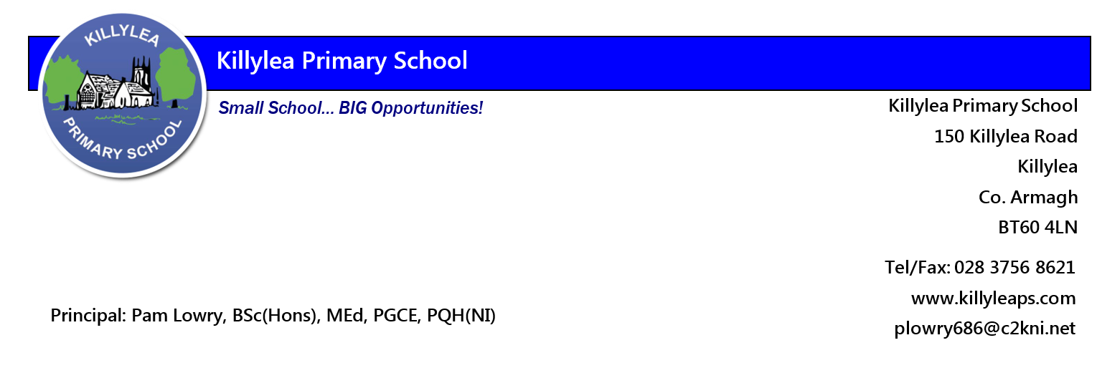
Letter to Parents/Carers 1st September 2020
Welcome to our official start to our new school year. How lovely to hear the classrooms buzzing with children’s voices! School is quite different this year with the operation of bubbles. Handwashing is taking a considerable amount of time out of our day and staff are not able to go easily from room to room. Please see below for information and guidance which will help us to run smoothly!
Parent Pay - we are having some teething difficulties but hopefully we will get all straightened out this week. P1 will be registered during next week once they begin.
Communication – during Covid, staff were willing to communicate over weekends and evenings but now that we are back in school, I would ask that parents keep communication to school hours 9am – 4pm and via the appropriate channels [See our Home School Communication policy]. Facebook messenger is NOT an appropriate means of communication.
Covid Helpline: 0300 555 0119 / 0300 555 0114. If your child has any of the recognised symptoms DO NOT SEND your child to school. Ring the helpline for advice and, if required, take a test. Staff are not qualified medics and parents should ring the helpline in the first instance. We all need to act responsibly to protect both pupils, families and staff.
Seesaw app: We ask that all families log on by this Friday. If you have mislaid the code, please ask your child’s teacher to re-issue it.
Outdoor Learning: All classes will be utilising the outdoors for learning. Therefore, your child will need a coat every-day. P1-4 should bring wellies to stay in school. We are providing outdoor trousers for P1-2 but suggest that P3-4 parents consider providing waterproof trousers for their own child [Lidl have fleece lined ones for £5.99 from Thursday].
Healthy Kids: we are delighted that our Healthy Kids programme will be up and running for all classes from Monday. Activities will be completed outdoors or if wet some mindfulness and health promotion lessons will take place in each classroom.
Return of books: Some pupils have yet to return reading/text books to school. Please ensure your child’s name is on them. Two pupils from last year’s P1/2 have still to return outdoor trousers.
Homework: staff will be assessing pupils over the next couple of weeks to assure your child gets the appropriate level of reading books etc. Homework will be posted via Seesaw app.
Absences: ALL absences must be explained by way of an email to the class teacher
sgraham300@c2kni.net pmiskelly105@c2kni.net lkerr536@c2kni.net
plowry686@c2kni.net gewart257@c2kni.net
Yours faithfully,
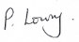

P. Lowry, principal

