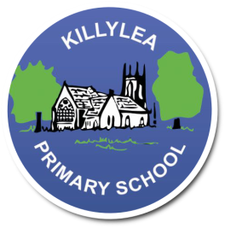
Killylea Primary School

Small School, Big Opportunities
Tel/Fax: 028 3756 8621
www.killyleaps.co.uk
plowry686@c2kni.net
Killylea Primary School
150 Killylea Road
Killylea
Co. Armagh
BT60 4LN

BT60 4LN

Website: www.killyleaps.co.uk
Killylea Primary School

19th October 2023
Dear P4-P7 Parents,
Our school choir (all P4-P7 welcome) will be singing at St Marks, Church of Ireland, Killylea Harvest on Friday 27th October, beginning at 7:30pm.
You are invited to come along and bring your child to this service.
Pupils who are singing with the choir must wear their full school uniform and bring a small collection. There will be supper after in the Church Hall.
Please ensure that all pupils who are taking part are at Church no later than 10 minutes before the service starts.
Please return the reply slip below to confirm attendance by tomorrow, Friday 20th October.
Yours Faithfully,
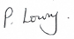
-------------------------------------------------------------------------------------------------------------------------------------------------
St Marks, Killylea Church Harvest Service – Friday 27th October 2023
Pupils name: ___________________________________

Please tick one option and return this form to school before Friday 20th October.

Will be attending

Will not be attending

Signed: __________________________________________________ Dated: __________________________

